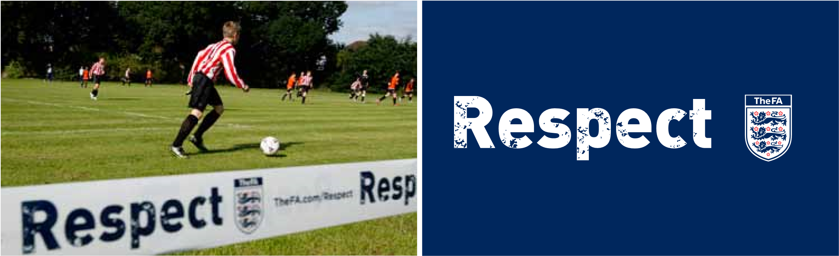
3. Responsible use of social networking sites
HAMPTON RANGERS JUNIORS | - inform the CWO if you have received inappropriate communications online, keeping a record of any inappropriate, threatening or offensive material as this may be needed as evidence.  Do not  Unless a child/young person is a direct relation, the coaches, managers, referees, medics and club officials should not:  - accept as a friend, players or referees U18 on social networking sites they are members of or share their own personal social networking sites with children or young people involved in youth football  - make contact with children or young people known through football outside of the football context on social networking sites  - use internet or web-based communications to send personal messages of a non-football nature to a child or young person  - engage in any personal communications, ‘banter’ or comments.  Further FA guidance is available on the following areas: 1 Social networking, websites, mobile phones, and email communications  - Running a website - Do’s and Don’ts  - Responsible use of Social Networking sites  - Communicating responsibly with Young Leaders, Coaches and Referees Under 18  - Using Texts and Emails with U18s – Do’s and Don’ts  - Guidance for parents/carers - Responsible use of text, email, and social networking sites  - Guidance for U18s using: Club Web Pages, Social Networks, Email and Texts  Acknowledgements  The FA would like to acknowledge that the development of this guidance has been assisted by guidance written by the Amateur  Swimming Association, England and Wales Cricket Board, Child  Protection in Sport Unit and Child Exploitation Online Protection centre.
The following guidance is provided not as an obstacle but to support clubs and leagues to manage their safeguarding responsibilities effectively. It aims to ensure children, young people, coaches, referees, and adults in a position of trust are not subjected to improper online behaviour or improper allegations.
If a club decides that the most effective way of communicating to young people is via a social networking site then the club is strongly advised to set up an account in the name of the club and explicitly for use by named club members, parents and carers solely about football matters e.g. fixtures, cancellations and team selection.
Coaches, referee mentors, club officials and others in a position of trust in football need to act responsibly both on and off the field and this includes the use of electronic communications.
Therefore, The FA would suggest that as a general principle coaches, managers etc should avoid using social networking sites as the primary way of communicating with players. Children and young people should be advised by their coaches, parents/carers and CWO to always tell an adult they trust about communications that make them feel uncomfortable or where they’ve been asked not to tell their parent/carer about the communication.
The following is best practice in relation to social networking.
Do
- Ensure all the privacy settings are locked so that the page(s) are used explicitly for club or league matters and are not used as a place to meet, share personal details, or have private conversations
- Nominate a club/league official to monitor the club/league social networking page regularly and remove access for anyone behaving inappropriately
- Make sure everyone within your club knows who is responsible for monitoring the content of the social networking areas and how to contact them
- Provide all users with The FAs best practice guidance on using social networking sites
TheFA.com/Footballsafe Let’s make football safe - not sorry

UPDATED JANUARY 2021
HAYLEIGH COWELL

